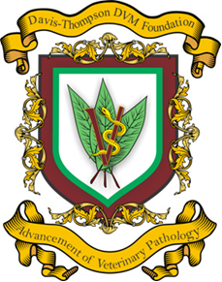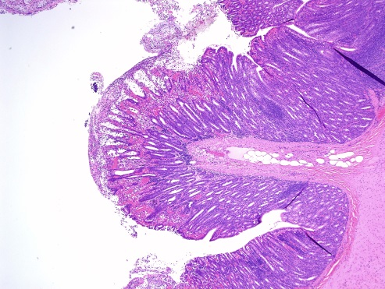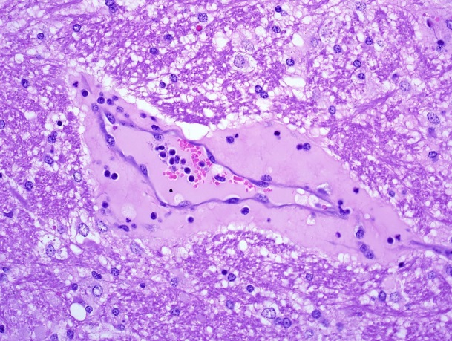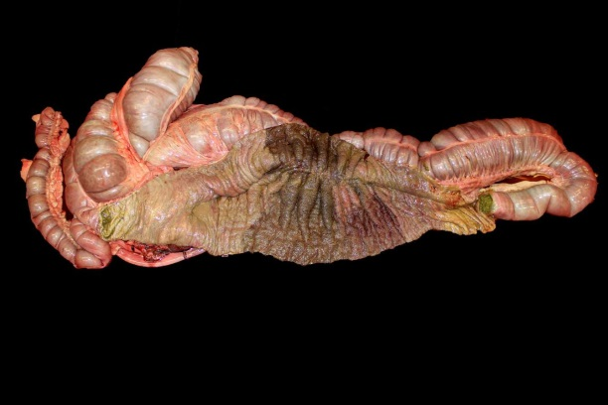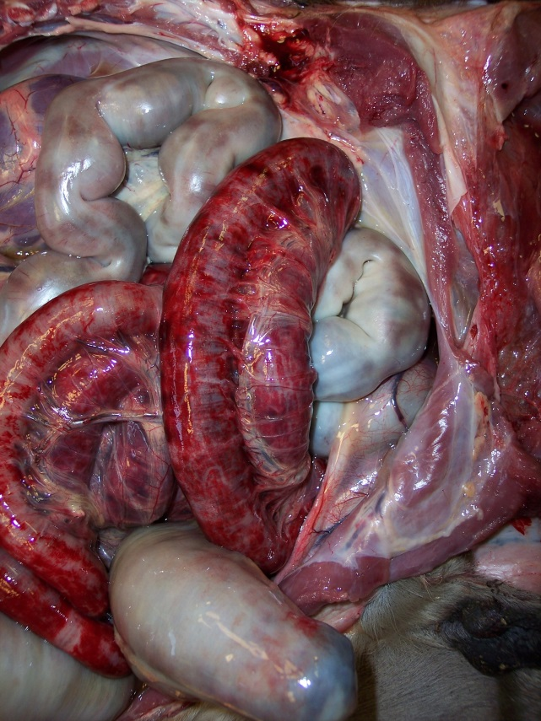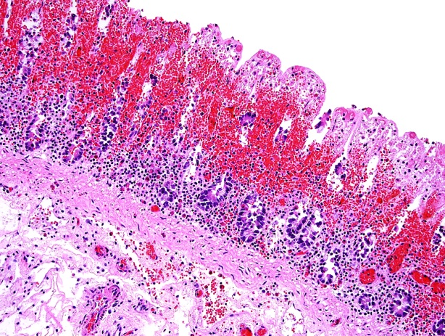

**Tuition: $150 includes pdfs of presentations, breaks, and   
8 hours of RACE-accredited CE.**

**Please register under:** [**http://www.regonline.com/2018AAVLD**](http://www.regonline.com/2018AAVLD)

**For more information:** [**http://www.cldavis.org/upcoming_meetings.html**](http://www.cldavis.org/upcoming_meetings.html)

**or email course director Dr. Paco Uzal at**

**fuzal@cahfs.ucdavis.edu**

***Equine enterocolitis***

***Microbiome***

***Small intestinal biopsies***

***Mechanisms of diarrhea***

***Neonatal diarrheas in   
cattle and horses***

**Faculty:**

**Francisco Uzal**

**Brandon Plattner**

**Jesse Hostetter**

***Clostridial enteric diseases***

**Given in association with the   
61st Annual Meeting of the AAVLD**

**October 19st, 2018 – Kansas City, MO**

This program has been submitted (but not yet approved) for 8 hours of continuing education credit in jurisdictions which recognize AAVSB RACE approval; however participants should be aware that some boards have limitations on the number of hours accepted in certain categories and/or restrictions on certain methods of delivery of continuing education. Call Dr. James Britt, 501-912-1449 for further information.”

**Davis Thompson, DVM Foundation**

6241 Formoor Lane , Gurnee, Illinois 60031-4757  
Phone: 301-467-4024 | Fax: 202-782-9010 | Toll Free:

williams@cldavis.org | http://www.cldavis.org

**18th Annual Davis Thompson Diagnostic Pathology Symposium: Diagnostic Gastrointestinal Pathology**

**Gastrointestinal Pathology**